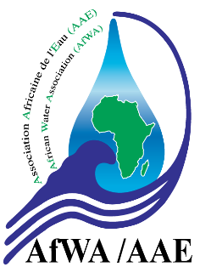
AFRICAN WATER ASSOCIATION
APPLICATION FORM FOR MEMBERSHIP

THE INDIVIDUAL MEMBER

(Please fill in, print, sign, stamp, then scan and send it back by email along with the attached form already registered)
jà)the)attached form already registered)

Utility: Click here to tap
Web Site: Click here to tap
Title:
Name: Click here to tap First names: Click here to tap

Office: Click here to tap

Tel: Click here to tap Mobile: Click here to tap
(Direct line)

Fax: Click here to tap Email: Click here to tap

Position: Click here to tap
Date and signature
(Actual)
Print and sign

* Please check one of the boxes below to mention
your choice for a Specialized Committee (SC).
(1) The Scientific and Technical Council (STC) is the permanent body of the African Water Association. It is made of the Members of the ASSOCIATION and its mission is to study Management, Juridical, Financial, Scientific and Technical issues related to the Water and Sanitation Sector, and likely to be faced by AfWA Members. In that regard, it organizes studies, technical sessions, carries out capacity building programs and seminars in order to propose solutions adapted to the various issues encountered in the sector. The STC produces customer supports and white papers and AfWA positioning documents in comparison with the African water and sanitation sector. The Scientific and Technical Council is composed of 3 Specialized Committees to which any AfWA member up to date with its contributions can belong to. Each Specialized Committee is directed by a bureau composed of a President, a Vice-president and 2 rapporteurs (an English-speaking and a French-speaking person). The members of the bureau are elected for a 2 years renewable term.

Any AfWA member up to date with its contributions can appoint among its staff representatives within the STC, in order to actively contribute to the reflection on the challenges relating to the water sector in Africa.

The STC meets twice (2) to three (3) times a year in an African capital city. Participation in the STC meetings is not compulsory for all the members of the Specialized Committees, but it is highly expected for the continuity of the works in progress.

Specialized Committee N°1 (SC1) Management: Responsible for the Institutional and Legal aspects, Finance, Quality and Human Resources, as well as the issues of a strategic nature of the Association.

Specialized Committee N°2 (SC2) Water Technical Management: Responsible for the technical aspects of the drinking water, production, transport, distribution and water quality services, technological innovations, normative and lawful aspects.

Specialized Committee N°3 (SC3) Sanitation and Environment Management: Fecal sludge management, technological innovations in sanitation, climate change, preservation of the resources, pollution and other subjects related to the normative and lawful monitoring of sanitation and environment etc.

